**Plugging into the Future: An Exploration of Electricity Consumption Patterns Using Tableau**

**Project Description**

"Plugging into the Future" is a data visualization project that explores electricity consumption patterns across various Indian states and regions using Tableau. By analyzing time-series data on electricity usage, this project reveals crucial trends such as time-of-day usage patterns, seasonal demand variations, and sector-wise consumption. These insights are instrumental for utility providers, policymakers, and consumers to optimize usage, enhance grid efficiency, and encourage sustainable energy consumption.

**Project Objectives**

* Identify peak and off-peak electricity usage times
* Understand seasonal variations in electricity demand
* Examine sector-wise electricity consumption
* Develop interactive dashboards and visual stories
* Enable data-driven decisions using visual insights

**Scenarios Covered**

**Scenario 1: Time-of-Day Usage Patterns**

* Analyze daily electricity consumption trends
* Identify peak and low-demand periods
* Aid in demand-side management and incentivize off-peak usage

**Scenario 2: Seasonal Variations and Forecasting**

* Track how electricity demand fluctuates over seasons
* Forecast consumption for future planning
* Align energy production (especially renewables) with demand patterns

**Scenario 3: Sector-Specific Consumption Insights**

* Break down usage across Residential, Commercial, and Industrial sectors
* Highlight the highest-consuming sectors
* Support sector-specific conservation policies and initiatives

**Project Flow**

**1. Problem Understanding**

* **Business Problem**: Lack of insight into electricity usage patterns leads to inefficient resource allocation.
* **Business Requirements**: Understand when, where, and why electricity is being consumed to make smarter energy decisions.

**2. Literature Survey & Impact**

* Explored reports and existing dashboards from energy departments and academic studies.
* **Social/Business Impact**: Promotes sustainable usage, ensures energy availability, reduces power outages, and optimizes operational costs.

**Data Collection & SQL Operations**

**🔗 Dataset Link**

<https://drive.google.com/file/d/1JxIkHNwXxjFztKq7ad0_KtkukCqTckNy/view?usp=sharing>

**Dataset Overview – Consumption.csv**

* **States**: Indian states
* **Regions**: Regional groups
* **Latitude/Longitude**: Geographical coordinates
* **Dates**: Time series from Jan 2, 2019, to Dec 5, 2020
* **Usage**: Power consumed in Mega Units (MU)

**SQL Integration Flow**

* Data stored in SQL Database
* Basic SQL operations performed (filtering, grouping, aggregations)
* Connected Tableau to the DB for real-time querying and dynamic data refresh

**Data Preparation**

**Steps Involved:**

* Removed irrelevant or null data
* Converted date formats to be compatible with Tableau time-series analysis
* Derived new columns (e.g., month, year, time slots)
* Handled missing values through interpolation where necessary
* Prepared separate tables for each scenario

**Data Visualizations**

Data was visualized using:

* Time Series Line Charts
* Heatmaps for time-of-day analysis
* Pie and Bar charts for sector-specific breakdown
* Map visualizations for region-wise comparisons

**Dashboard :**

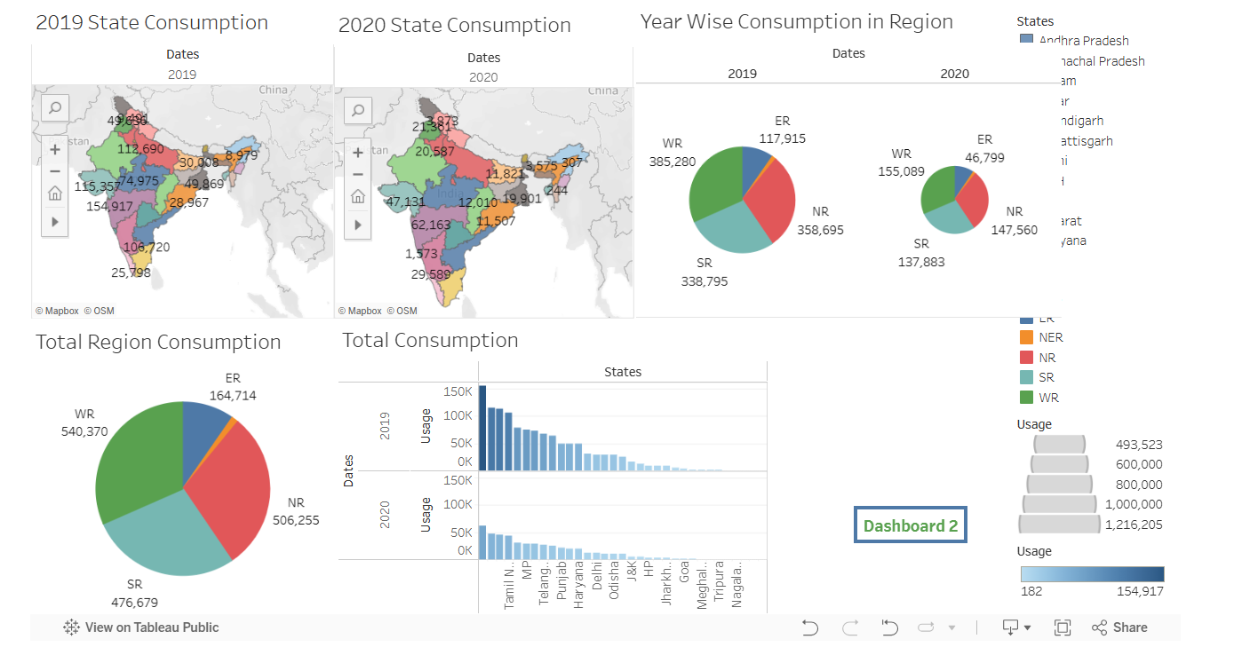

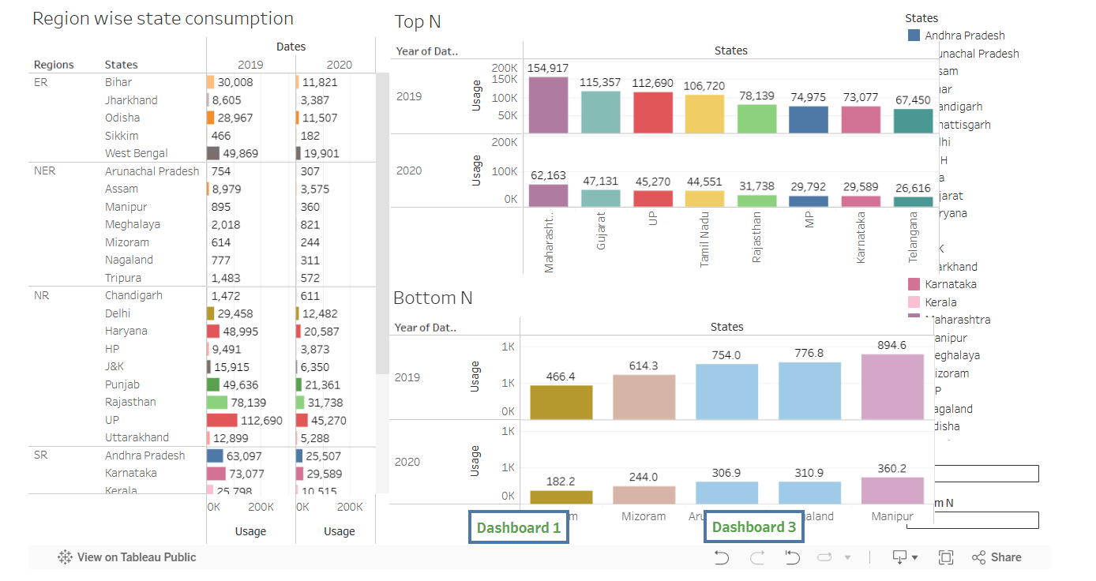

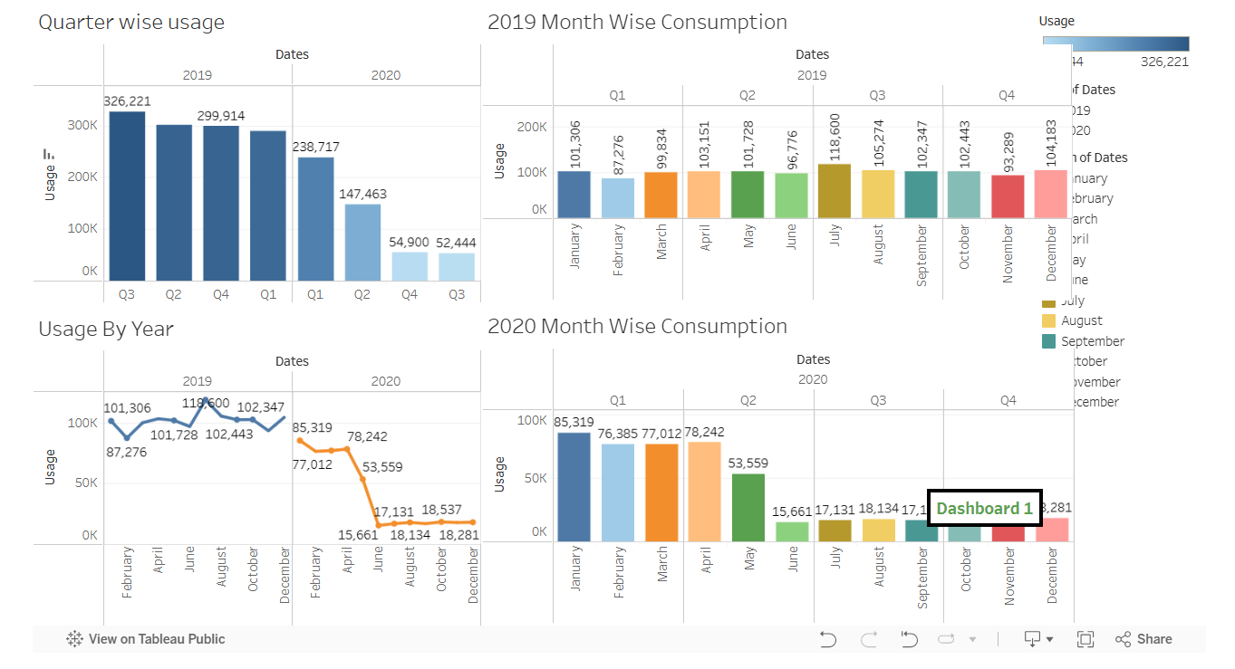

The dashboards were designed to be:

* Interactive and user-friendly
* Responsive for various devices
* Equipped with filters for time range, state, sector, and region
* Real-time insights using live data connections (via SQL)

**Dashboard Features:**

* KPIs for total usage, peak demand, etc.
* Drill-down capabilities by date and sector
* Region-based comparison using map views

**Story**

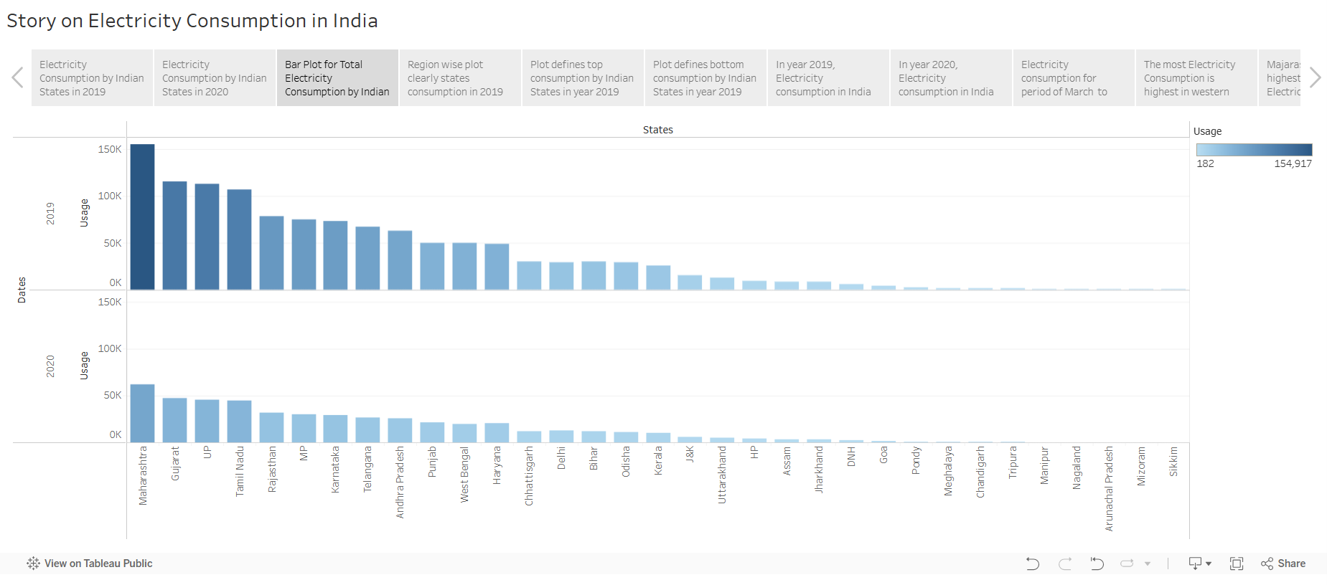

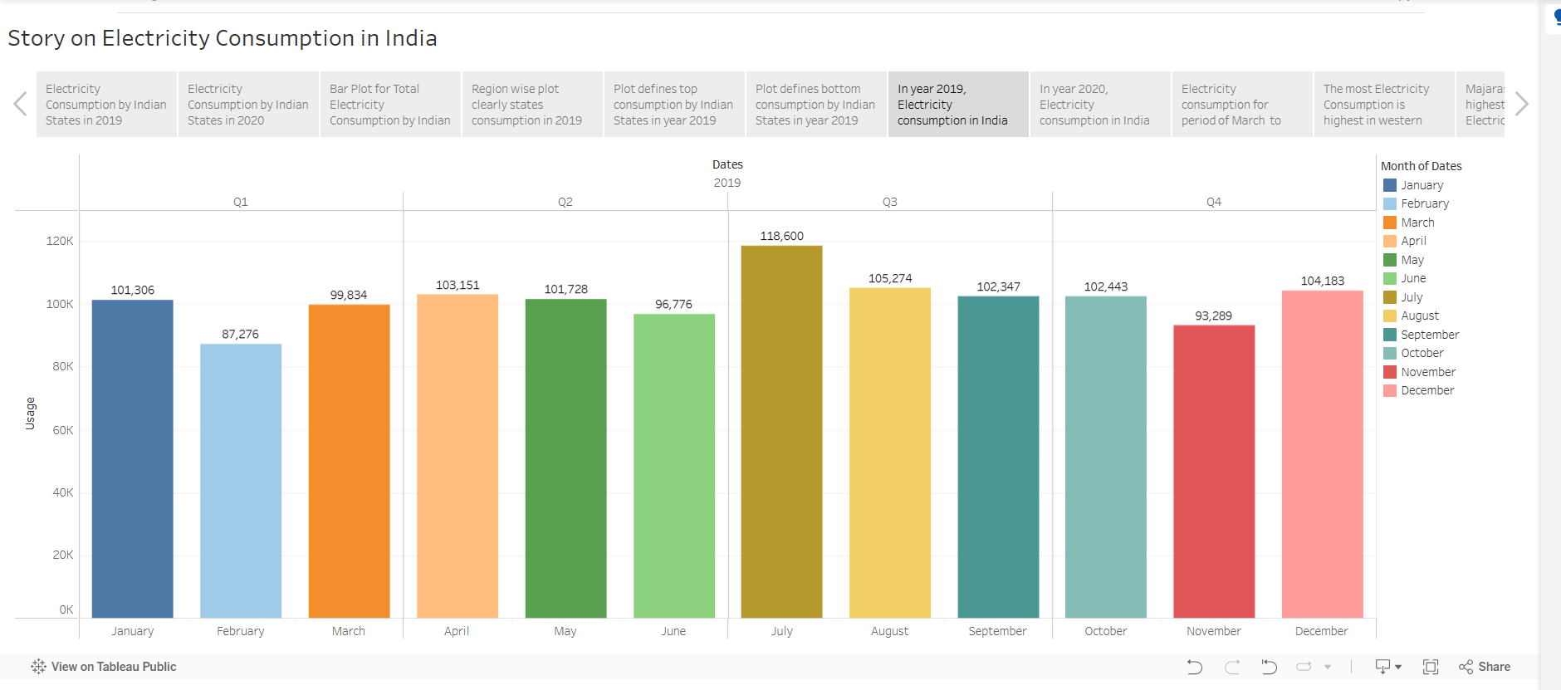

The data story consists of multiple scenes illustrating:

1. Overall consumption patterns
2. Peak hours and load distribution
3. Seasonal trends
4. Regional insights
5. Sectoral breakdown

**Story Structure:**

* **Intro**: Problem statement and dataset overview
* **Scene 1**: Daily usage patterns
* **Scene 2**: Seasonal analysis
* **Scene 3**: Region-wise and sector-wise visualization
* **Conclusion**: Summary of insights and suggested actions

**Performance Testing**

* **Amount of Data Rendered**: ~24 months of time-series data for all Indian states
* **Calculation Fields**: Created 10+ calculated fields for monthly usage, YOY trends, percent change, etc.
* **Filters Utilized**: Region, State, Sector, Date Range
* **No. of Visualizations**: 15+ visualizations used across dashboards and story scenes

**Web Integration**

**Steps to Publish to Tableau Public:**

1. Open the dashboard or story in Tableau.
2. Click the **Share** button on the top ribbon.
3. Login to Tableau Public with your credentials.
4. Publish the workbook. The respective sheet will be visible online.

**Purpose:**

* Share with stakeholders
* Embed on websites or blogs
* Promote awareness and engagement with public energy data

**Deployed Link** - <https://india-electricity-insights-web.lovable.app>